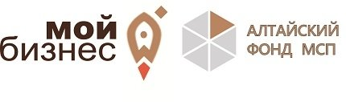

Приглашаем посетить выставку-ярмарку пищевой промышленности, садоводства, сельского и лесного хозяйства «Зеленая неделя 2020»
Выставка пройдет с 17 по 26 января 2020 года. Ее организатор - выставочная фирма Messe Berlin GmbH проводит выставку с 1926 года. За последнее время особенно высок интерес к вышеуказанным направлениям со стороны профессиональных посетителей из стран ЦВЕ.
Разделы выставки:
- продукты питания и напитки со всего мира;
- вина и алкогольные напитки;
- мясо-молочная продукция;
- чаи, травы и специи;
- морские продукты;
- семена;
- сельскохозяйственная техника и инвентарь;
- оборудование для теплиц и садоводства;
животноводство;
- оборудование и приспособления для домашнего хозяйства.
Центр поддержки экспорта субсидирует оплату аренды выставочного стенда, дополнительного оборудования и дизайна для компаний, являющихся субъектами малого и среднего предпринимательства, зарегистрированными на территории Алтайского края.

Подать заявку

https://мойбизнес22.рф/tsentr-podderzhki-eksporta/?spush=ZGFuaWxvdmF0OTBAbWFpbC5ydQ==

