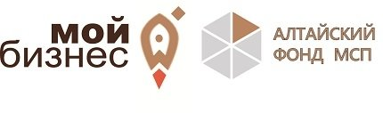
Дата проведения: 13 февраля 2020 года  Место проведения: центр Мой бизнес,  Барнаул, ул. Мало-Тобольская, 19. | 13 ФЕВРАЛЯ: СЕМИНАР ДЛЯ МАЛОГО БИЗНЕСА «ВОЗМОЖНОСТИ ДЛЯ ВАС И ВАШЕГО БИЗНЕСА»  Программа семинара:  - Программа субсидирования МЭР 8,5 (Минэкономразвития Алтайского края)  - Меры государственной поддержки для субъектов МСП (Минэкономразвития Алтайского края)  - Поддержка субъектов малого предпринимательства, предоставляемая Алтайским фондом развития малого и среднего предпринимательства  - Программы кредитования ПАО Сбербанк- возможности для развития бизнеса  - Экосистема Сбербанка - удобные сервисы для повседневной жизни и бизнеса

Зарегистрироваться по ссылке

https://мойбизнес22.рф/calendar/13-fevralya-seminar-dlya-klientov-malogo-biznesa-vozmozhnosti-dlya-vas-i-vashego-biznesa/?spush=ZGFuaWxvdmF0OTBAbWFpbC5ydQ==

